**RSA Algorithm Design Document**

* RSA Algorithm is algorithm used for public-key encryption.
* It is the most popular asymmetric algorithm depends on the mathematical fact.
* In this first Sender creates Encryption Keys using available Public Keys and converts a normal plain text into **Cipher text** using them.
* Then the Sender shares Cipher Text & Encryption keys to Receiver.
* Receiver decrypts the Cipher text into plain text using received encryption keys.

**Sequence Diagram for RSA Algorithm**

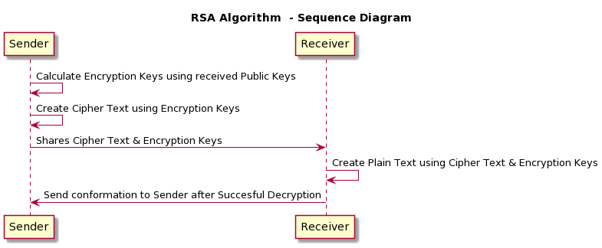

Fig. 1.1

**Class Diagram for RSA Algorithm**

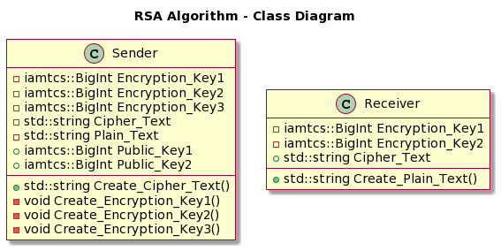

Fig 1.2